**Exporting Test cases to ALM from MS-EXCEL in bulk**

1. Confirm if you have Add-Ins tab in MS-EXCEL

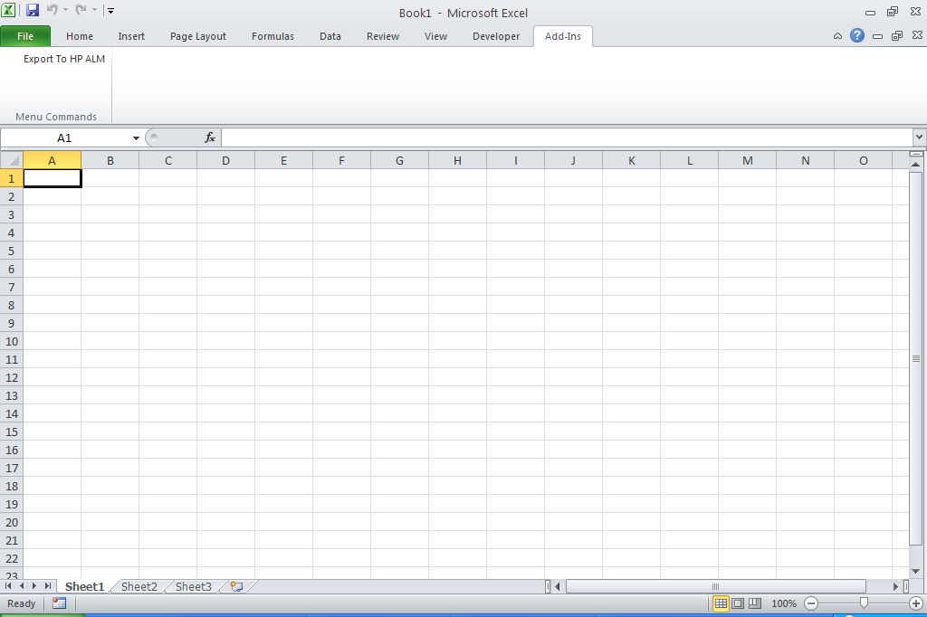

1. Prepare your test case data in the below format into EXCEL sheet1:

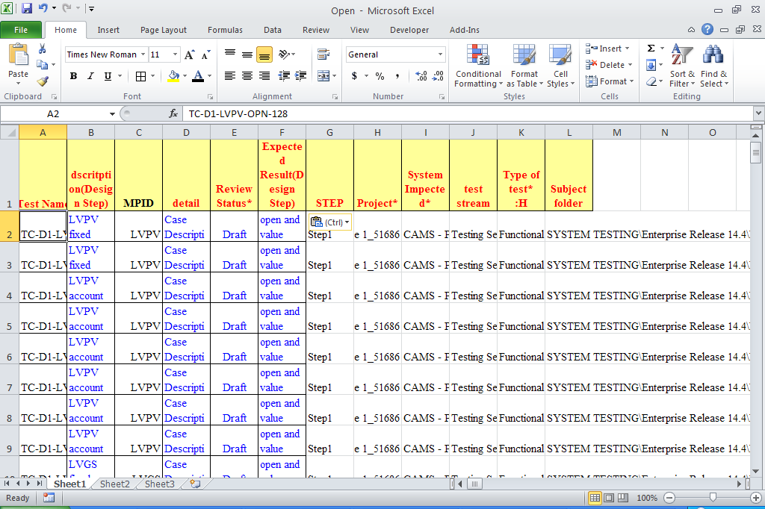

***ATTACHED*** ***IS THE MICROSOFT EXCEL SHEET FOR REFERENCE.***



1. ***If you have more than one steps to be added in design step of ALM for a test case, prepare data as below by duplicating the rows and keeping the test case id (column A) same for both rows.***

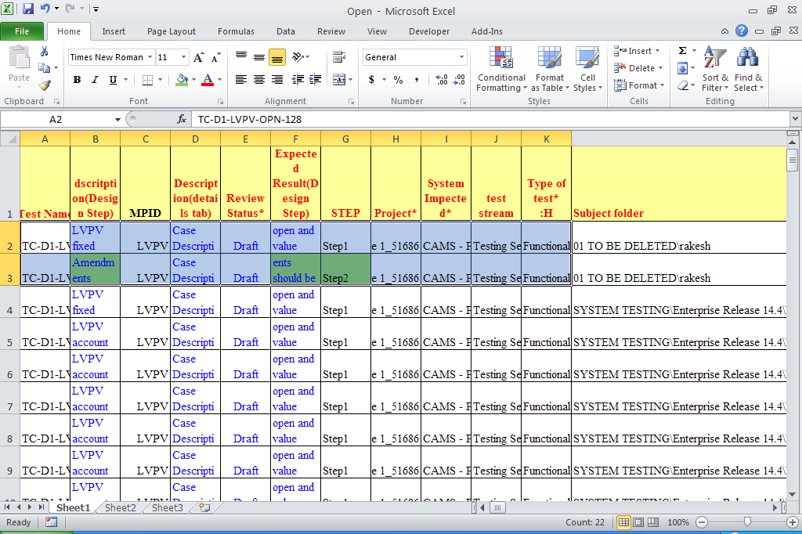

***Duplicate row for which more than one step are required, make changes in column B, F, G (highlighted in GREEN shown above).***

1. Copy only data (exclude header row)

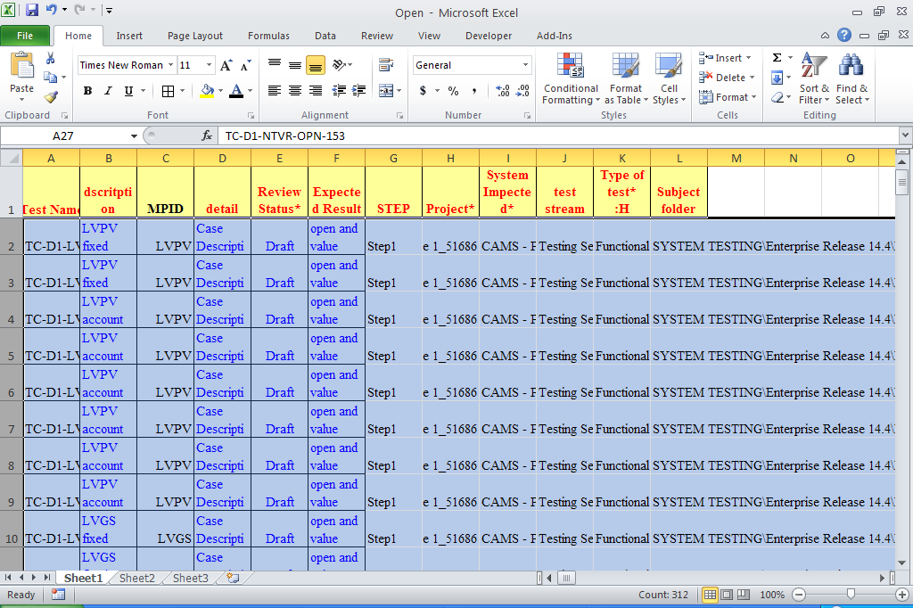

1. Use Paste special (values) to paste data into sheet2:

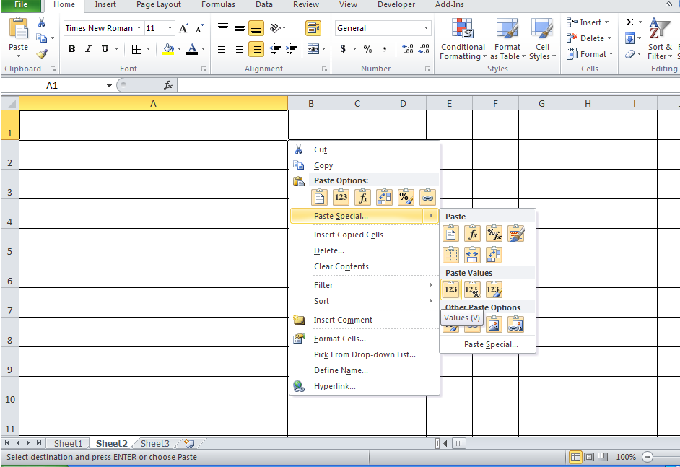

1. Prepare a mapping in Sheet3 of Excel as below:

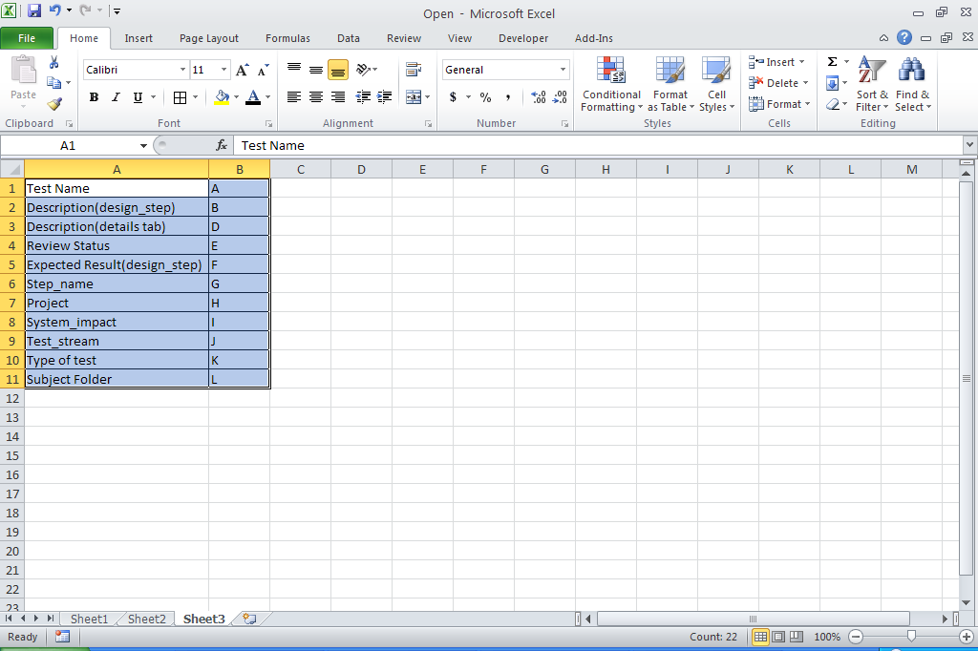

Refer this sheet to mapping Excel Columns to ALM required fields.

1. Select all rows to be exported to ALM

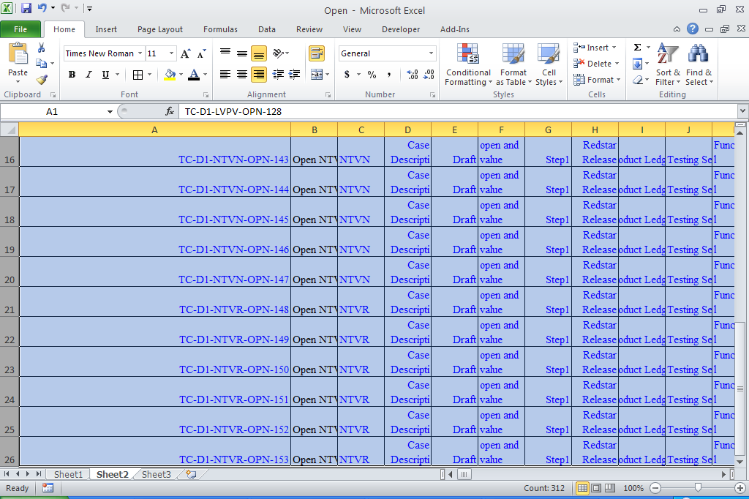

Select option **Export to HP ALM** from **Add-Ins** tab

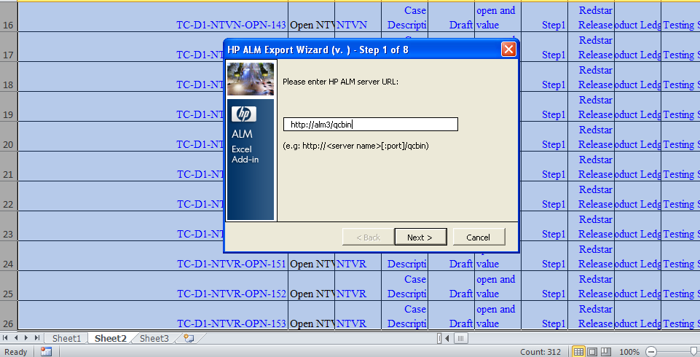

1. 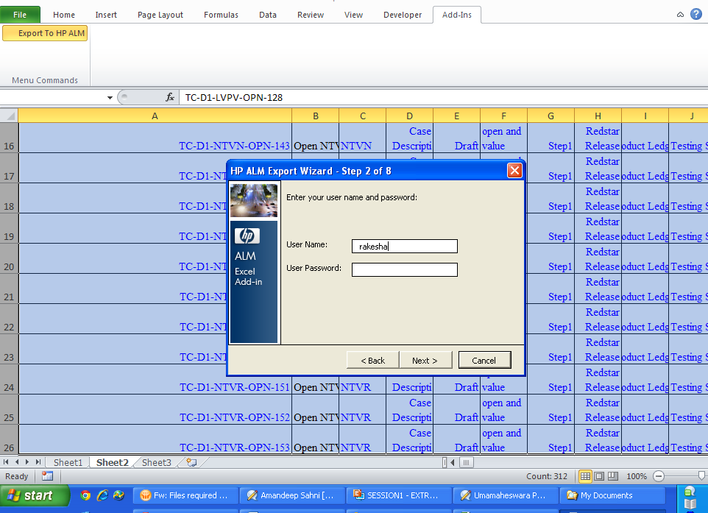
2. 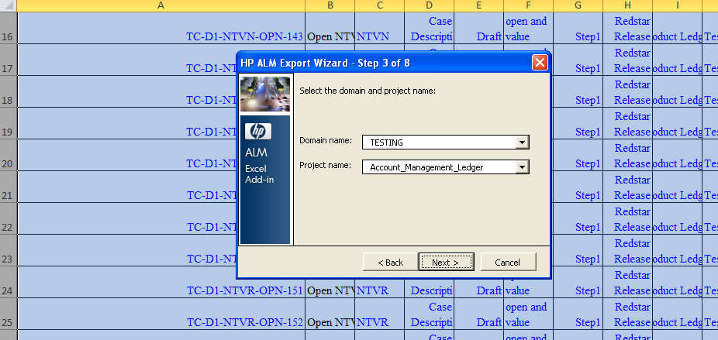

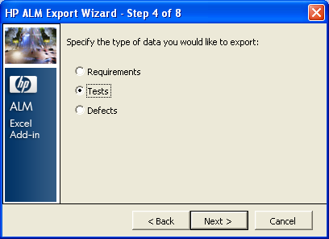

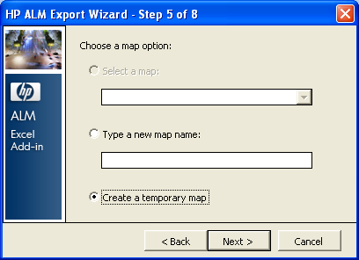

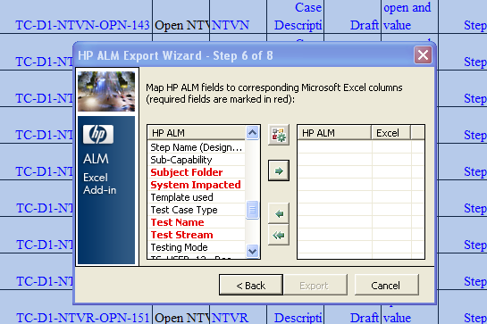

Use below mapping to map EXCEL columns to ALM required fields

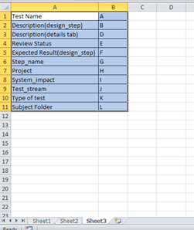

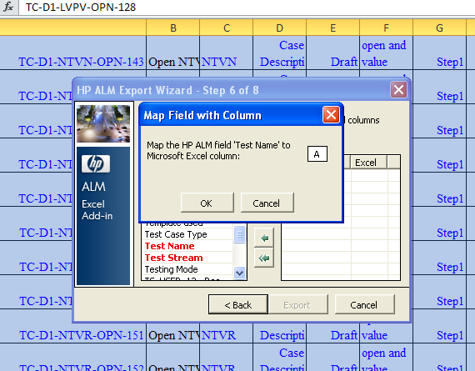

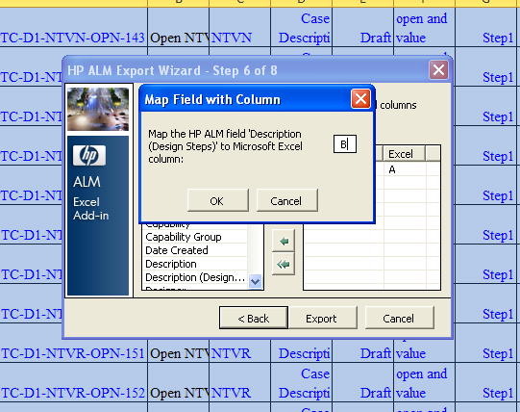

Similarly map all the required fields of HP ALM to Microsoft Excel columns.

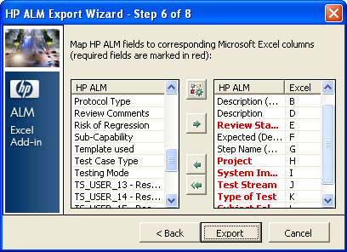

1. After mapping all the HP ALM fields to Microsoft Excel columns, click on EXPORT

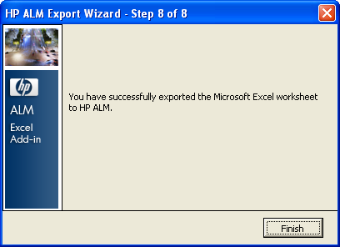

1. Verify test cases exported to HP ALM under subject folder specified in column ‘L’ of EXCEL.

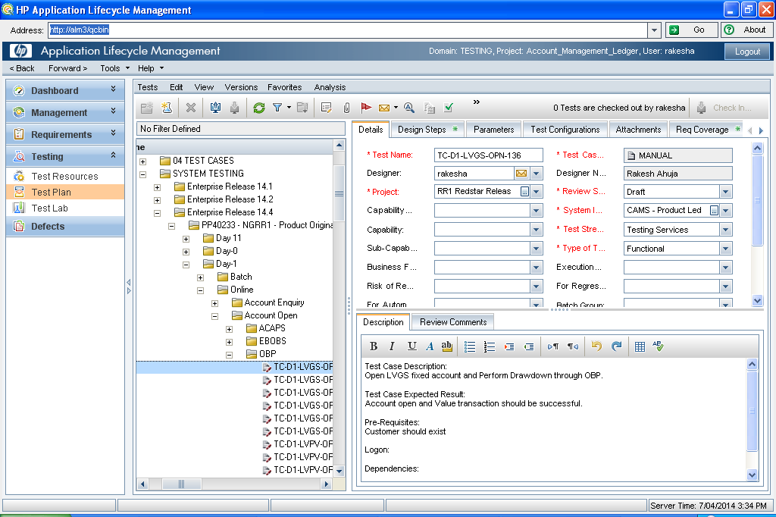

***If a test case has more than one step in design steps:***

